Greedy Algorithms
Coin Change, Fractional Knapsack, Job Sequencing with Deadlines, Huffman Coding
Dr. Pradeep Kumar S

1. Coin Change – Supermarket Billing
A supermarket cashier wants to return minimum coins for a customer’s balance amount.
Input:
Coins = [1, 2, 5, 10]
Amount = 28
Output:
10 10 5 2 1
Minimum coins = 5

2. Coin Change – Parking Meter
A parking meter accepts coins of fixed denominations. Find the minimum coins needed.
Input:
Coins = [1, 5, 10, 25]
Amount = 63
Output:
25 25 10 1 1 1
Minimum coins = 6

3. Coin Change – Ticket Counter
A ticket counter must return change using available coin denominations.
Input:
Coins = [1, 3, 7, 10]
Amount = 24
Output:
10 10 3 1
Minimum coins = 4

4. Fractional Knapsack – Food Delivery Truck
A truck can carry limited weight. Select food packets to maximize profit.
Input:
Weights = [10, 20, 30]
Profits = [60, 100, 120]
Capacity = 50
Output:
Maximum profit = 240

5. Fractional Knapsack – Gold Transport
A courier transports gold items with maximum value under weight limit.
Input:
Weights = [5, 10, 15]
Profits = [30, 40, 45]
Capacity = 20
Output:
Maximum profit = 80

6. Fractional Knapsack – Relief Material Loading
Relief items must be loaded to maximize importance value.
Input:
Weights = [4, 8, 2, 6]
Profits = [20, 40, 14, 30]
Capacity = 10
Output:
Maximum profit = 54

7. Job Sequencing – Software Company Tasks
A company wants to schedule tasks before deadlines to earn maximum profit.
Input:
Jobs = A B C D
Deadlines = [2, 1, 2, 1]
Profits = [100, 19, 27, 25]
Output:
Selected jobs = C A
Maximum profit = 127

8. Job Sequencing – Exam Paper Evaluation
Teachers must evaluate papers before deadlines to maximize reward.
Input:
Jobs = J1 J2 J3 J4 J5
Deadlines = [2, 1, 2, 1, 3]
Profits = [20, 15, 10, 5, 1]
Output:
Selected jobs = J2 J1 J5
Maximum profit = 36

9. Job Sequencing – Printing Press Orders
A printing press schedules orders based on deadlines and profit.
Input:
Jobs = A B C D E
Deadlines = [2, 1, 2, 1, 3]
Profits = [100, 50, 10, 20, 30]
Output:
Selected jobs = B A E
Maximum profit = 180

10. Job Sequencing – Freelance Projects
A freelancer can complete one project per day and wants maximum income.
Input:
Jobs = P1 P2 P3 P4
Deadlines = [1, 1, 2, 2]
Profits = [40, 30, 20, 10]
Output:
Selected jobs = P1 P3
Maximum profit = 60

11. Huffman Coding – Text Compression
Generate Huffman codes for characters used in file compression.
Input:
Characters = a b c d e f
Frequencies = [5, 9, 12, 13, 16, 45]
Output:
Huffman Codes:
f: 0
c: 100
d: 101
a: 1100
b: 1101
e: 111

12. Huffman Coding – Message Encoding
A messaging app compresses frequently used symbols using Huffman coding.
Input:
Characters = A B C D
Frequencies = [10, 20, 30, 40]
Output:
Huffman Codes:
D: 0
C: 10
A: 110
B: 111

13. Huffman Coding – Sensor Data Compression
IoT sensor data symbols must be compressed using minimum bits.
Input:
Characters = x y z w
Frequencies = [7, 8, 14, 25]
Output:
Huffman Codes:
w: 0
z: 10
x: 110
y: 111

14. Coin Change – Vending Machine
A vending machine gives minimum coins as change.
Input:
Coins = [1, 2, 5]
Amount = 11
Output:
5 5 1
Minimum coins = 3

15. Fractional Knapsack – Warehouse Packing
A warehouse manager selects items to maximize value within capacity.
Input:
Weights = [2, 3, 5, 7]
Profits = [10, 5, 15, 7]
Capacity = 8
Output:
Maximum profit = 30

1. def coin_change(coins, amount):
coins.sort(reverse=True)

result = []

for coin in coins:
while amount >= coin:
amount -= coin
result.append(coin)

return result

# Input
coins = [1, 2, 5, 10]
amount = 28

coins_used = coin_change(coins, amount)

print("Coins used:", *coins_used)
print("Minimum coins =", len(coins_used))

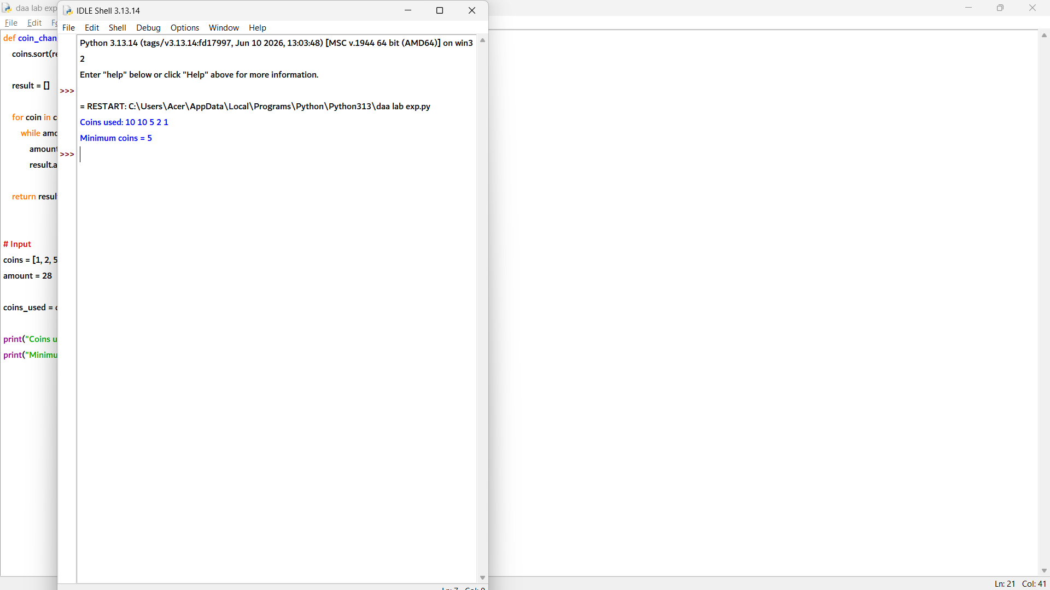

2. def coin_change(coins, amount):
coins.sort(reverse=True)

result = []

for coin in coins:
while amount >= coin:
amount -= coin
result.append(coin)

return result

# Input
coins = [1, 5, 10, 25]
amount = 63

coins_used = coin_change(coins, amount)

print("Coins used:", *coins_used)
print("Minimum coins =", len(coins_used))

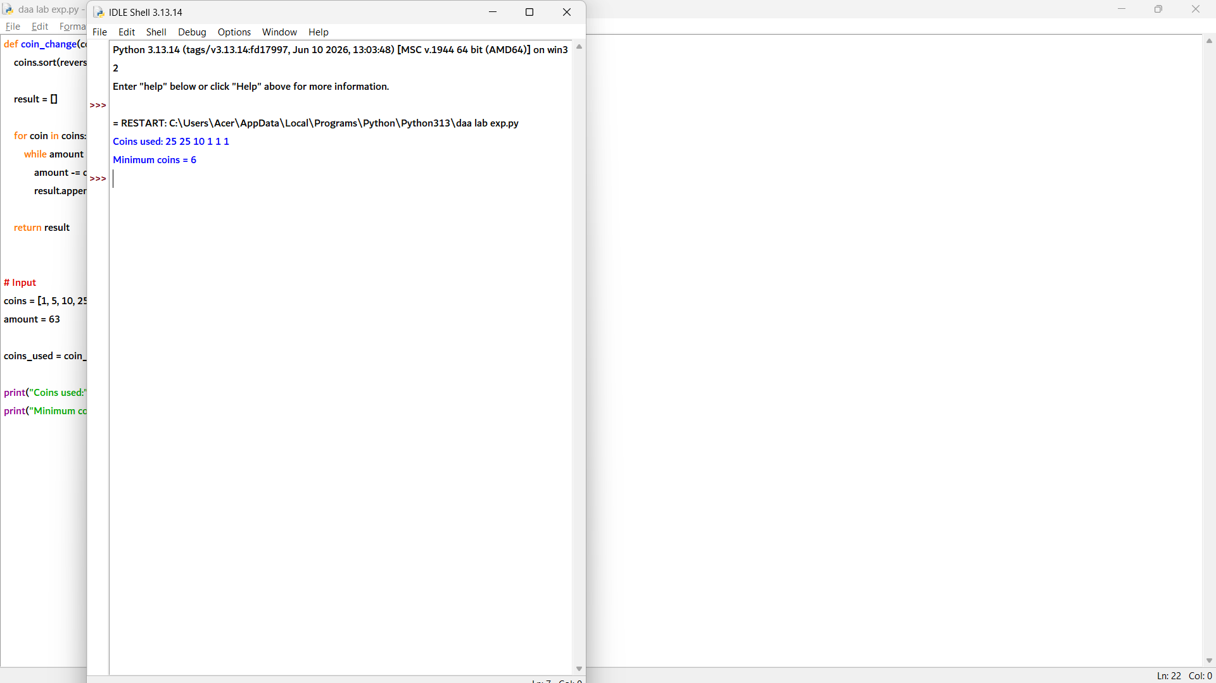

3. def coin_change(coins, amount):
coins.sort(reverse=True)

result = []

for coin in coins:
while amount >= coin:
amount -= coin
result.append(coin)

return result

# Input
coins = [1, 3, 7, 10]
amount = 24

coins_used = coin_change(coins, amount)

print("Coins used:", *coins_used)
print("Minimum coins =", len(coins_used))

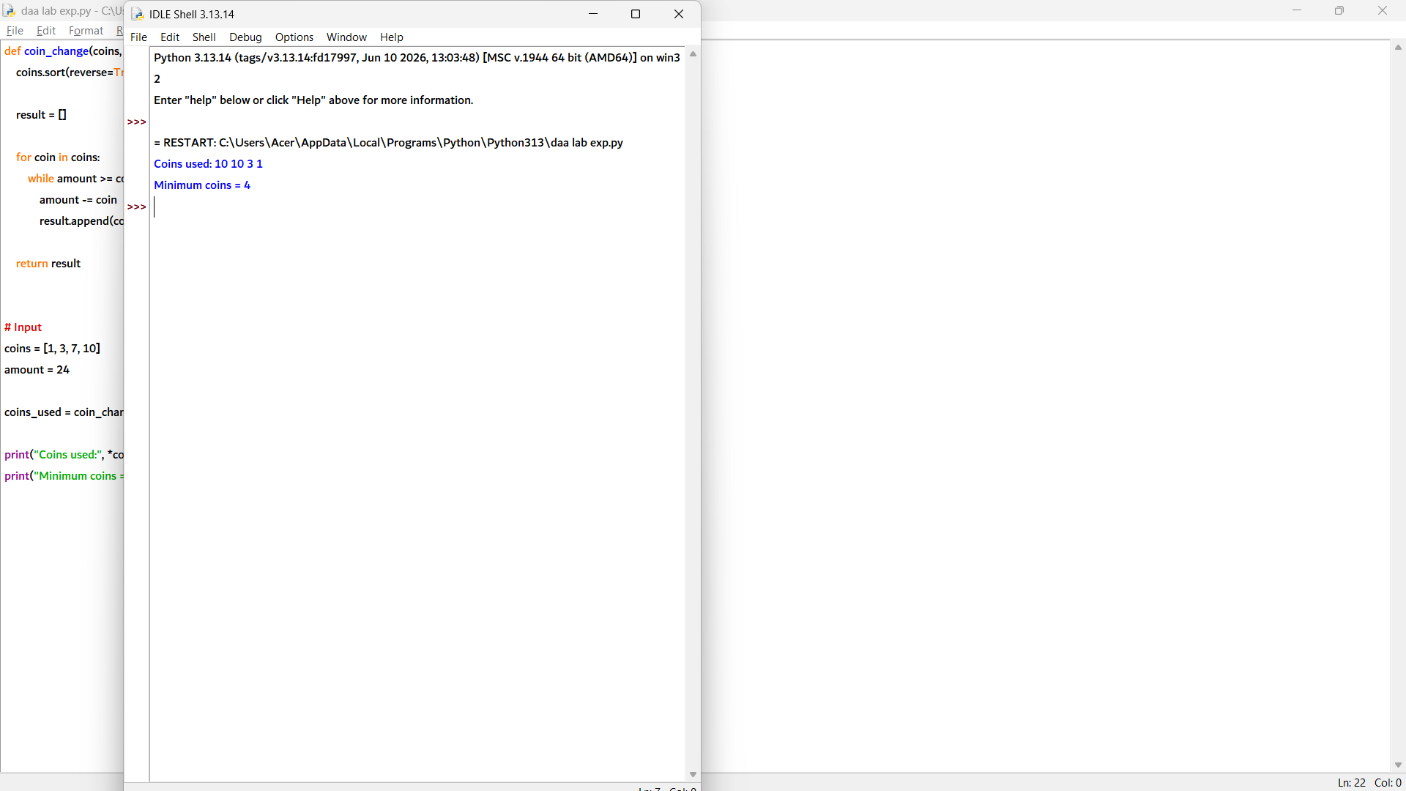

4. def fractional_knapsack(weights, profits, capacity):
n = len(weights)

# Calculate profit/weight ratio
items = []

for i in range(n):
items.append((profits[i] / weights[i], weights[i], profits[i]))

# Sort by highest profit ratio
items.sort(reverse=True)

total_profit = 0

for ratio, weight, profit in items:
if capacity >= weight:
capacity -= weight
total_profit += profit
else:
fraction = capacity / weight
total_profit += profit * fraction
break

return total_profit

# Input
weights = [10, 20, 30]
profits = [60, 100, 120]
capacity = 50

print("Maximum profit =", fractional_knapsack(weights, profits, capacity))

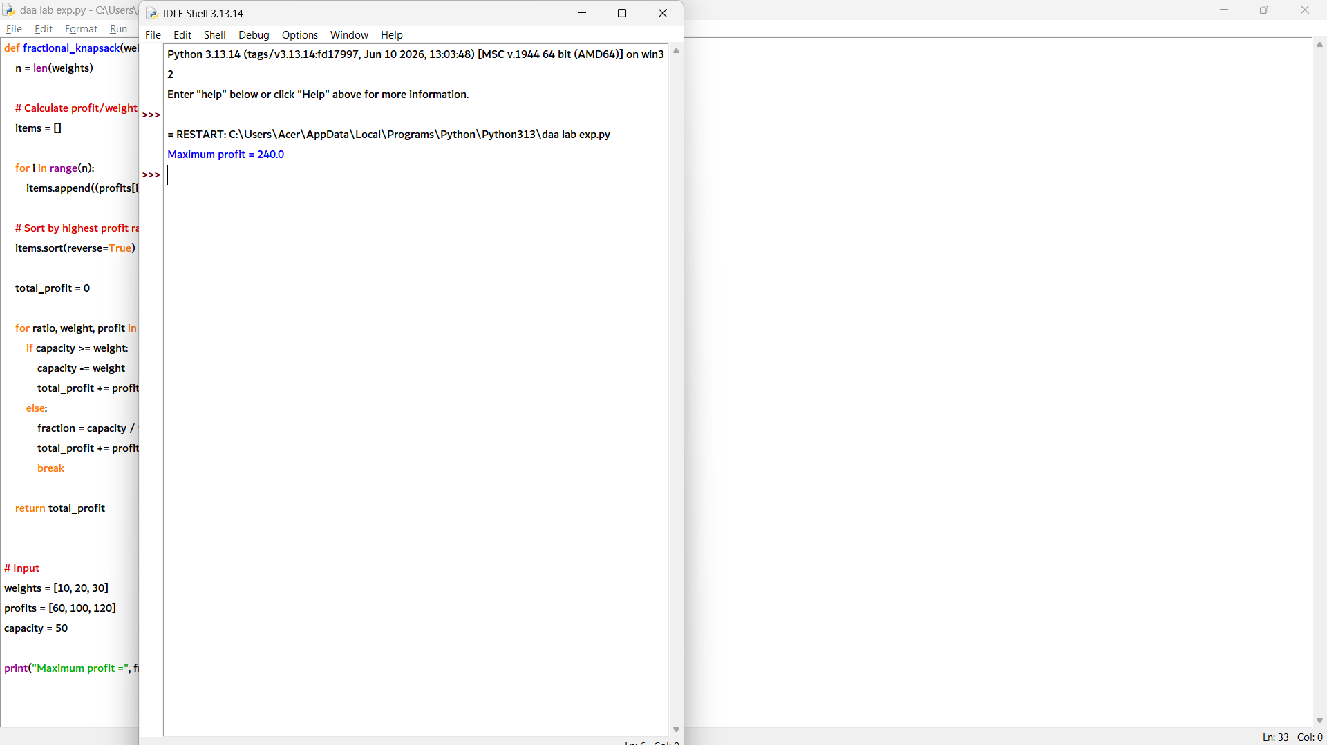

5. def fractional_knapsack(weights, profits, capacity):
n = len(weights)

# Store profit/weight ratio
items = []

for i in range(n):
items.append((profits[i] / weights[i], weights[i], profits[i]))

# Sort by highest ratio
items.sort(reverse=True)

total_profit = 0

for ratio, weight, profit in items:
if capacity >= weight:
capacity -= weight
total_profit += profit
else:
fraction = capacity / weight
total_profit += profit * fraction
break

return total_profit

# Input
weights = [5, 10, 15]
profits = [30, 40, 45]
capacity = 20

print("Maximum profit =", fractional_knapsack(weights, profits, capacity))

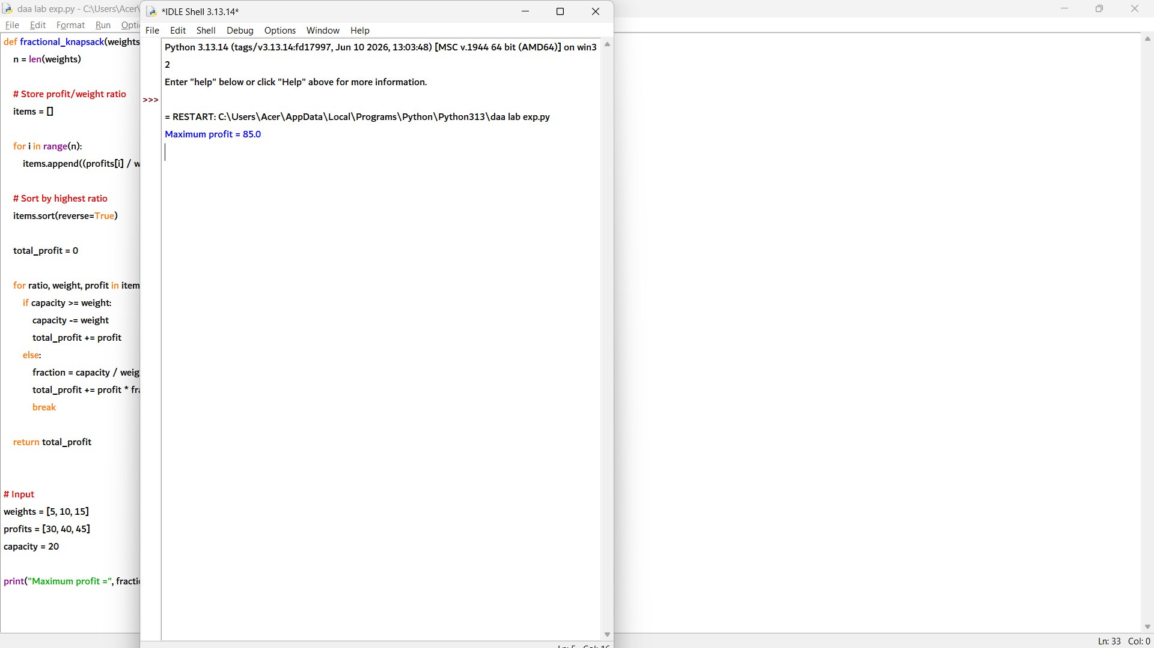

6def fractional_knapsack(weights, profits, capacity):
n = len(weights)

# Calculate profit/weight ratio
items = []

for i in range(n):
items.append((profits[i] / weights[i], weights[i], profits[i]))

# Sort by highest profit ratio
items.sort(reverse=True)

total_profit = 0

for ratio, weight, profit in items:
if capacity >= weight:
capacity -= weight
total_profit += profit
else:
fraction = capacity / weight
total_profit += profit * fraction
break

return total_profit

# Input
weights = [4, 8, 2, 6]
profits = [20, 40, 14, 30]
capacity = 10

print("Maximum profit =", fractional_knapsack(weights, profits, capacity))

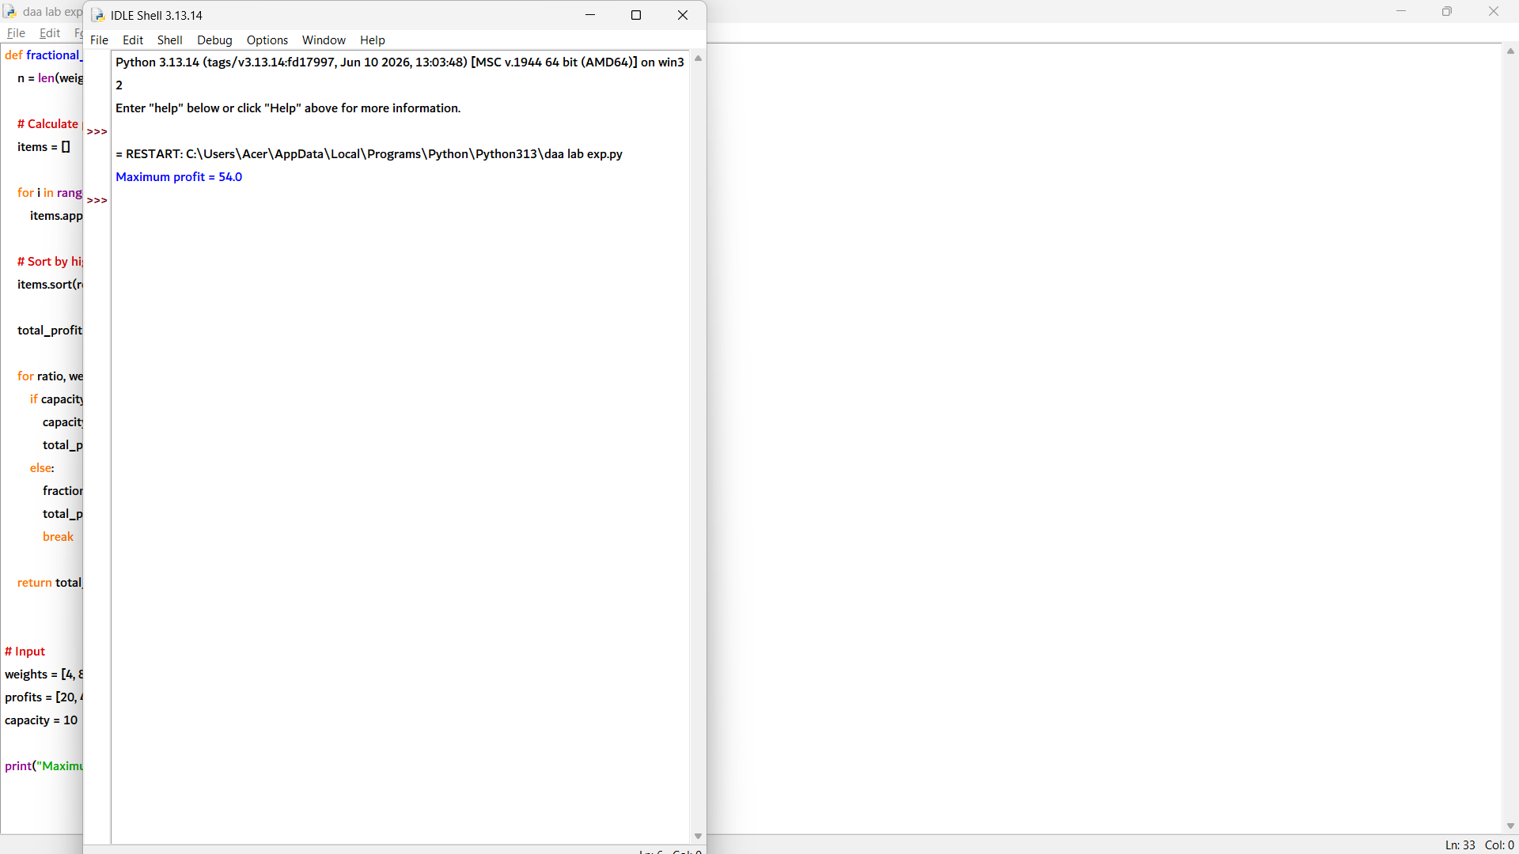

7. def job_sequencing(jobs, deadlines, profits):
n = len(jobs)

# Combine job details
job_list = []

for i in range(n):
job_list.append((profits[i], deadlines[i], jobs[i]))

# Sort jobs by maximum profit
job_list.sort(reverse=True)

# Find maximum deadline
max_deadline = max(deadlines)

# Slots for jobs
slots = [None] * max_deadline

total_profit = 0
selected_jobs = []

# Schedule jobs
for profit, deadline, job in job_list:
for j in range(min(deadline, max_deadline) - 1, -1, -1):
if slots[j] is None:
slots[j] = job
total_profit += profit
selected_jobs.append(job)
break

return selected_jobs, total_profit

# Input
jobs = ['A', 'B', 'C', 'D']
deadlines = [2, 1, 2, 1]
profits = [100, 19, 27, 25]

selected, profit = job_sequencing(jobs, deadlines, profits)

print("Selected jobs =", *selected)
print("Maximum profit =", profit)

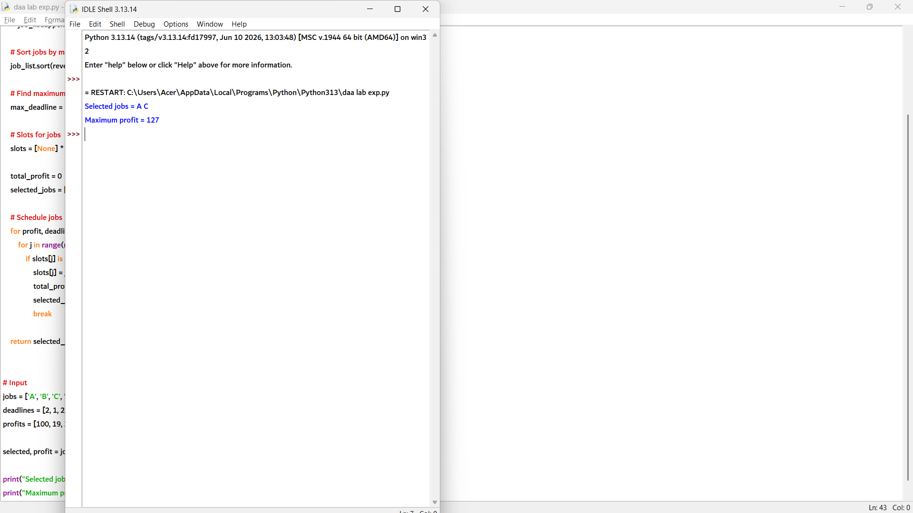

8. def job_sequencing(jobs, deadlines, profits):
n = len(jobs)

# Combine job details
job_list = []

for i in range(n):
job_list.append((profits[i], deadlines[i], jobs[i]))

# Sort jobs by decreasing profit
job_list.sort(reverse=True)

# Maximum deadline
max_deadline = max(deadlines)

# Create time slots
slots = [None] * max_deadline

total_profit = 0
selected_jobs = []

# Schedule jobs
for profit, deadline, job in job_list:
for j in range(min(deadline, max_deadline) - 1, -1, -1):
if slots[j] is None:
slots[j] = job
total_profit += profit
selected_jobs.append(job)
break

return selected_jobs, total_profit

# Input
jobs = ['J1', 'J2', 'J3', 'J4', 'J5']
deadlines = [2, 1, 2, 1, 3]
profits = [20, 15, 10, 5, 1]

selected, profit = job_sequencing(jobs, deadlines, profits)

print("Selected jobs =", *selected)
print("Maximum profit =", profit)

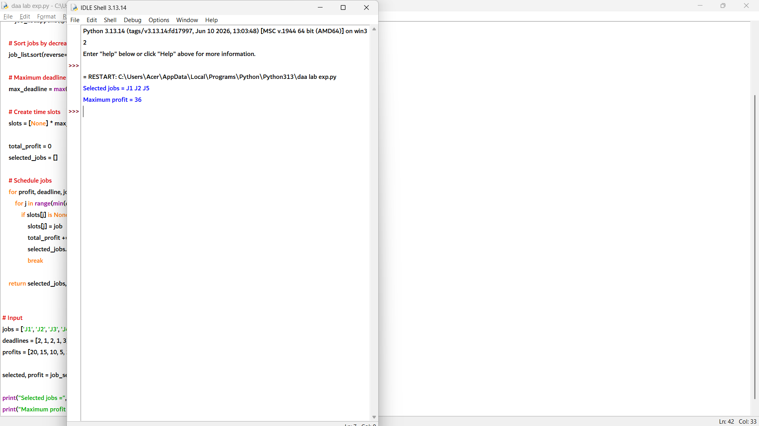

def job_sequencing(jobs, deadlines, profits):
n = len(jobs)

# Combine job details
job_list = []

for i in range(n):
job_list.append((profits[i], deadlines[i], jobs[i]))

# Sort jobs by decreasing profit
job_list.sort(reverse=True)

# Find maximum deadline
max_deadline = max(deadlines)

# Create time slots
slots = [None] * max_deadline

total_profit = 0
selected_jobs = []

# Schedule jobs
for profit, deadline, job in job_list:
for j in range(min(deadline, max_deadline) - 1, -1, -1):
if slots[j] is None:
slots[j] = job
total_profit += profit
selected_jobs.append(job)
break

return selected_jobs, total_profit

# Input
jobs = ['A', 'B', 'C', 'D', 'E']
deadlines = [2, 1, 2, 1, 3]
profits = [100, 50, 10, 20, 30]

selected, profit = job_sequencing(jobs, deadlines, profits)

print("Selected jobs =", *selected)
print("Maximum profit =", profit)

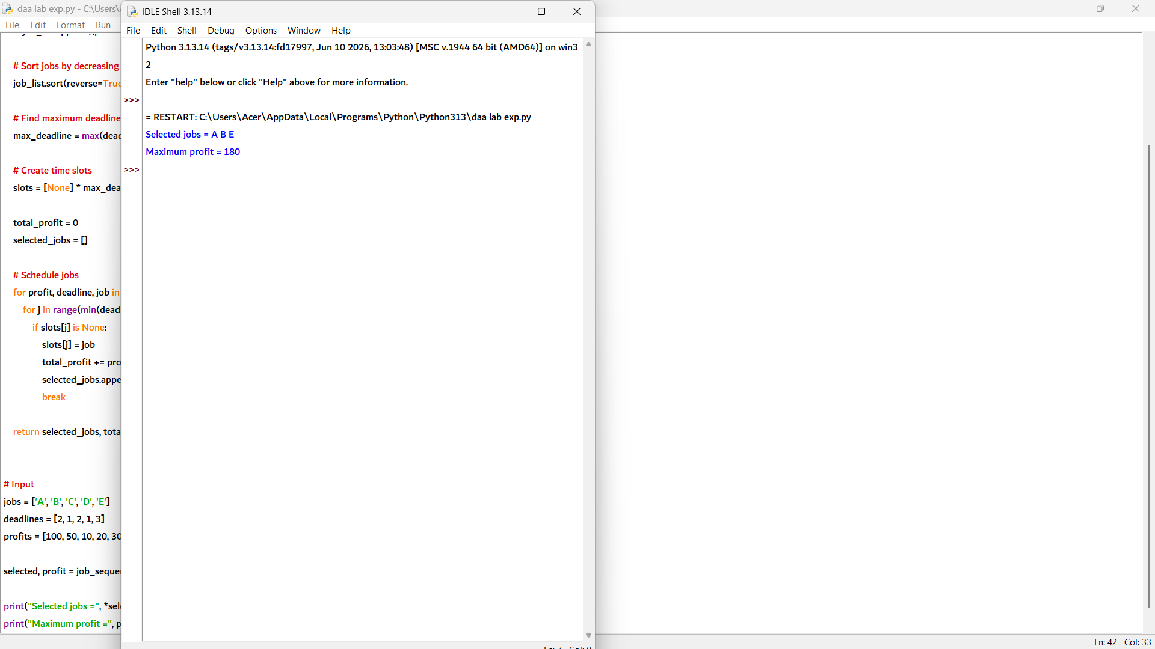

def job_sequencing(jobs, deadlines, profits):
n = len(jobs)

# Combine job details
job_list = []

for i in range(n):
job_list.append((profits[i], deadlines[i], jobs[i]))

# Sort jobs by decreasing profit
job_list.sort(reverse=True)

# Find maximum deadline
max_deadline = max(deadlines)

# Create available time slots
slots = [None] * max_deadline

total_profit = 0
selected_jobs = []

# Schedule jobs
for profit, deadline, job in job_list:
for j in range(min(deadline, max_deadline) - 1, -1, -1):
if slots[j] is None:
slots[j] = job
total_profit += profit
selected_jobs.append(job)
break

return selected_jobs, total_profit

# Input
jobs = ['P1', 'P2', 'P3', 'P4']
deadlines = [1, 1, 2, 2]
profits = [40, 30, 20, 10]

selected, profit = job_sequencing(jobs, deadlines, profits)

print("Selected jobs =", *selected)
print("Maximum profit =", profit)

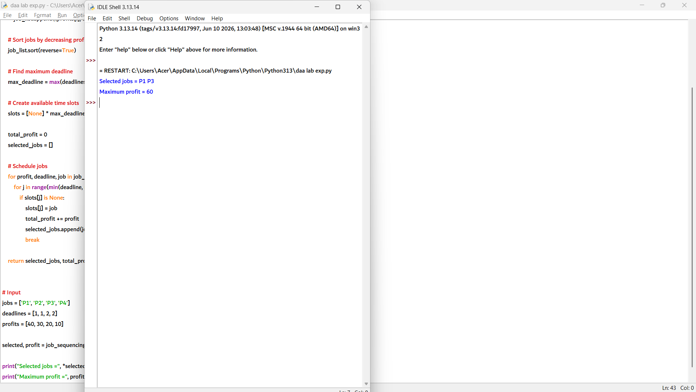

11. import heapq

def huffman_coding(chars, freq):
heap = []

# Create min heap
for i in range(len(chars)):
heap.append((freq[i], chars[i], ""))

heapq.heapify(heap)

# Build Huffman tree
while len(heap) > 1:
f1, c1, code1 = heapq.heappop(heap)
f2, c2, code2 = heapq.heappop(heap)

heapq.heappush(
heap,
(f1 + f2, c1 + c2, "")
)

# Generate codes recursively
codes = {}

def generate(node, code):
if len(node) == 1:
codes[node] = code
else:
mid = len(node) // 2
generate(node[:mid], code + "0")
generate(node[mid:], code + "1")

# Build tree using frequencies
heap = [(freq[i], chars[i]) for i in range(len(chars))]
heapq.heapify(heap)

tree = {}

while len(heap) > 1:
f1, c1 = heapq.heappop(heap)
f2, c2 = heapq.heappop(heap)

tree[c1 + c2] = (c1, c2)

heapq.heappush(heap, (f1 + f2, c1 + c2))

def assign_codes(symbols, code):
if len(symbols) == 1:
codes[symbols] = code
return

left, right = tree[symbols]
assign_codes(left, code + "0")
assign_codes(right, code + "1")

root = heap[0][1]
assign_codes(root, "")

return codes

# Input
characters = ['a', 'b', 'c', 'd', 'e', 'f']
frequencies = [5, 9, 12, 13, 16, 45]

codes = huffman_coding(characters, frequencies)

print("Huffman Codes:")
for ch in sorted(codes, key=lambda x: frequencies[characters.index(x)], reverse=True):
print(ch + ":", codes[ch])

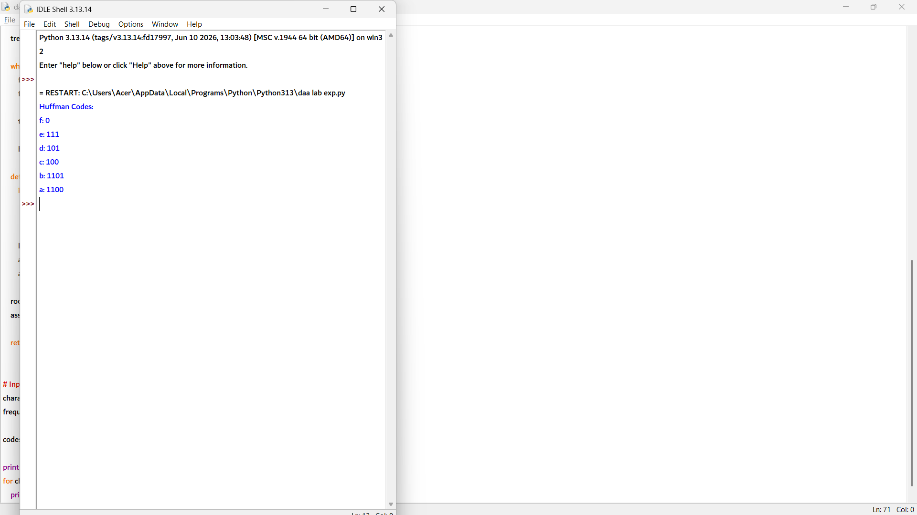

12. import heapq

def huffman_coding(chars, freq):
heap = []

# Create heap with frequency and character
for i in range(len(chars)):
heap.append((freq[i], chars[i]))

heapq.heapify(heap)

# Store tree relationships
tree = {}

# Build Huffman tree
while len(heap) > 1:
f1, c1 = heapq.heappop(heap)
f2, c2 = heapq.heappop(heap)

merged = c1 + c2
tree[merged] = (c1, c2)

heapq.heappush(heap, (f1 + f2, merged))

codes = {}

# Generate codes
def generate(symbols, code):
if len(symbols) == 1:
codes[symbols] = code
return

left, right = tree[symbols]
generate(left, code + "0")
generate(right, code + "1")

root = heap[0][1]
generate(root, "")

return codes

# Input
characters = ['A', 'B', 'C', 'D']
frequencies = [10, 20, 30, 40]

codes = huffman_coding(characters, frequencies)

print("Huffman Codes:")
for ch in sorted(codes, key=lambda x: frequencies[characters.index(x)], reverse=True):
print(ch + ":", codes[ch])

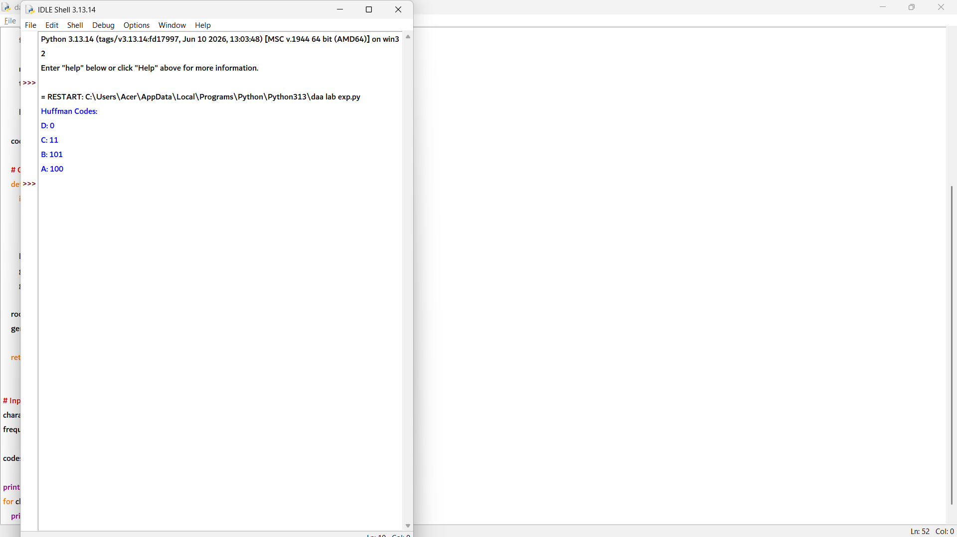

13. import heapq

def huffman_coding(chars, freq):
heap = []

# Create min heap
for i in range(len(chars)):
heap.append((freq[i], chars[i]))

heapq.heapify(heap)

tree = {}

# Build Huffman Tree
while len(heap) > 1:
f1, c1 = heapq.heappop(heap)
f2, c2 = heapq.heappop(heap)

merged = c1 + c2
tree[merged] = (c1, c2)

heapq.heappush(heap, (f1 + f2, merged))

codes = {}

# Generate Huffman codes
def generate(symbols, code):
if len(symbols) == 1:
codes[symbols] = code
return

left, right = tree[symbols]
generate(left, code + "0")
generate(right, code + "1")

root = heap[0][1]
generate(root, "")

return codes

# Input
characters = ['x', 'y', 'z', 'w']
frequencies = [7, 8, 14, 25]

codes = huffman_coding(characters, frequencies)

print("Huffman Codes:")
for ch in sorted(codes, key=lambda x: frequencies[characters.index(x)], reverse=True):
print(ch + ":", codes[ch])

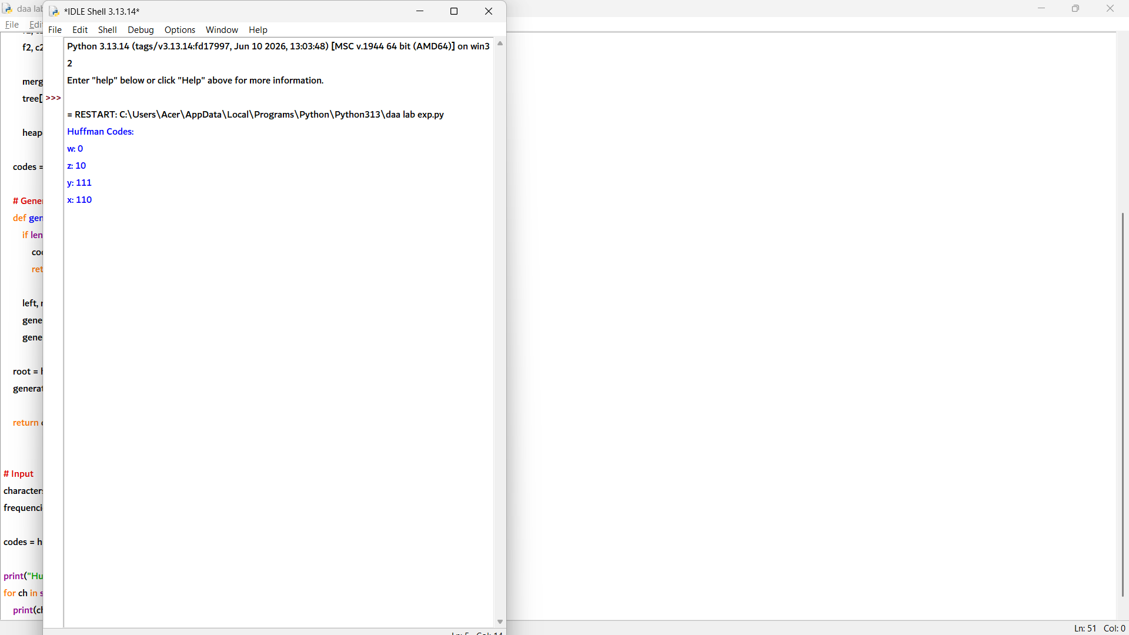

14. def coin_change(coins, amount):
coins.sort(reverse=True)

result = []

for coin in coins:
while amount >= coin:
amount -= coin
result.append(coin)

return result

# Input
coins = [1, 2, 5]
amount = 11

coins_used = coin_change(coins, amount)

print("Coins used:", *coins_used)
print("Minimum coins =", len(coins_used))

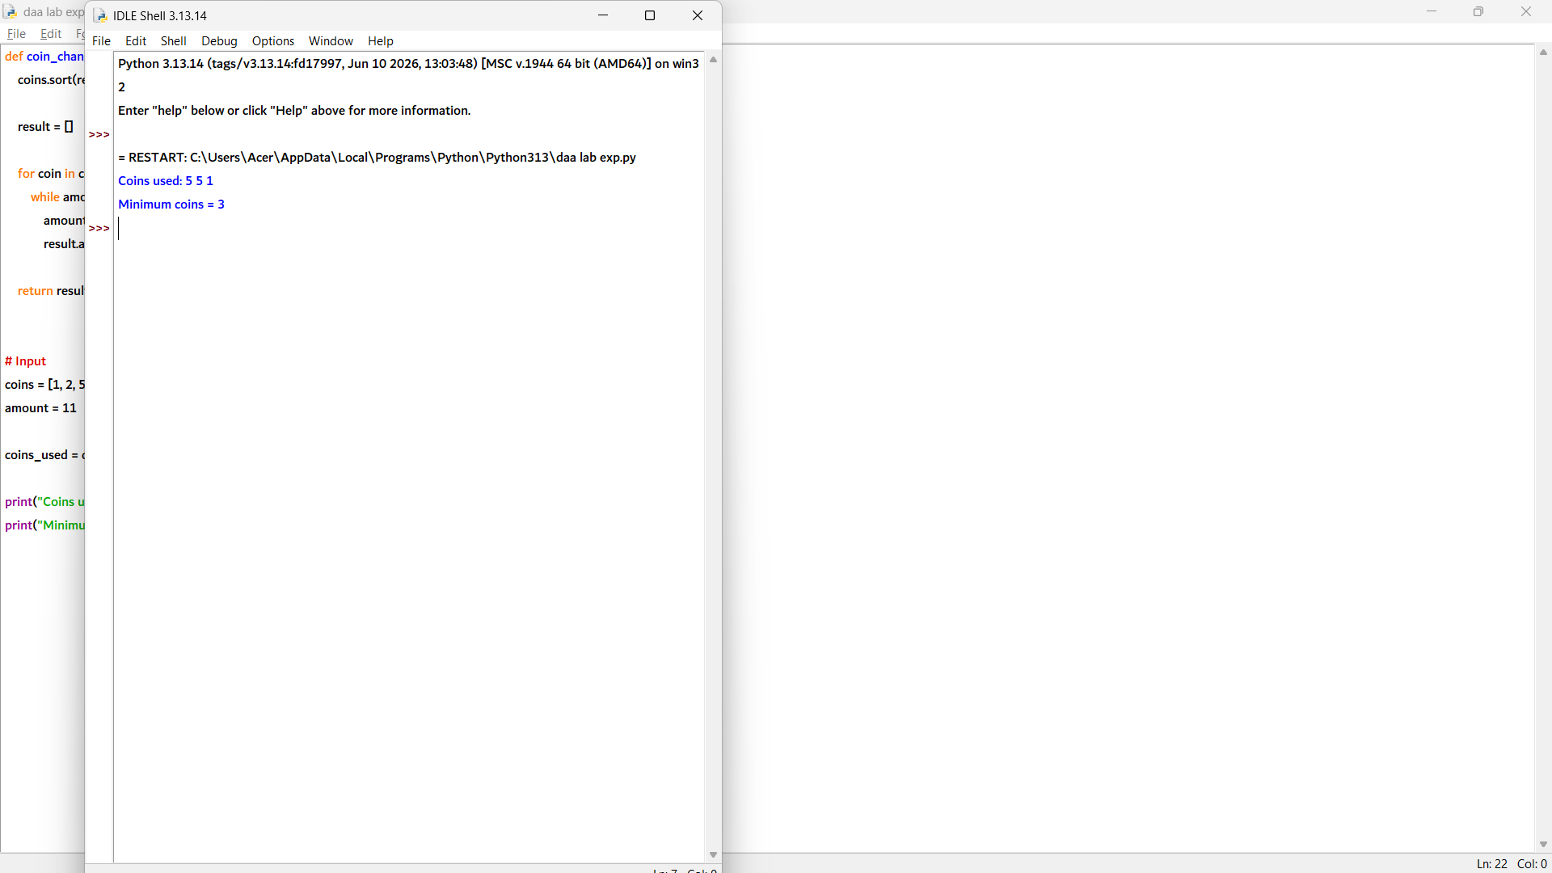

15. def fractional_knapsack(weights, profits, capacity):
n = len(weights)

# Calculate profit/weight ratio
items = []

for i in range(n):
items.append((profits[i] / weights[i], weights[i], profits[i]))

# Sort items by highest profit ratio
items.sort(reverse=True)

total_profit = 0

for ratio, weight, profit in items:
if capacity >= weight:
capacity -= weight
total_profit += profit
else:
fraction = capacity / weight
total_profit += profit * fraction
break

return total_profit

# Input
weights = [2, 3, 5, 7]
profits = [10, 5, 15, 7]
capacity = 8

print("Maximum profit =", fractional_knapsack(weights, profits, capacity))

